Neural Networks & Deep Learning

Assignment – 4

Name : Sravani Mannuru

Student Id : 700766162

Github Link: https://github.com/sravs2031/Neural-Networks-ICP4.git

Video Link: https://drive.google.com/file/d/1uDU3FUwF4NytDRDyofeXcREhflvN-tF1/view?usp=drive_link

Screenshots:

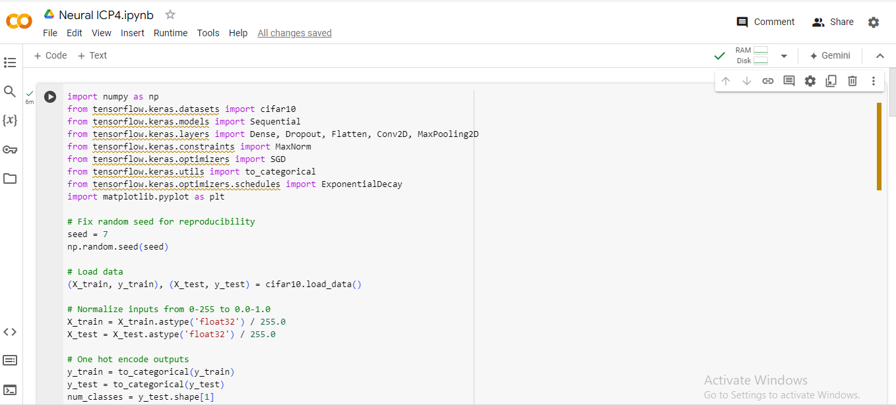

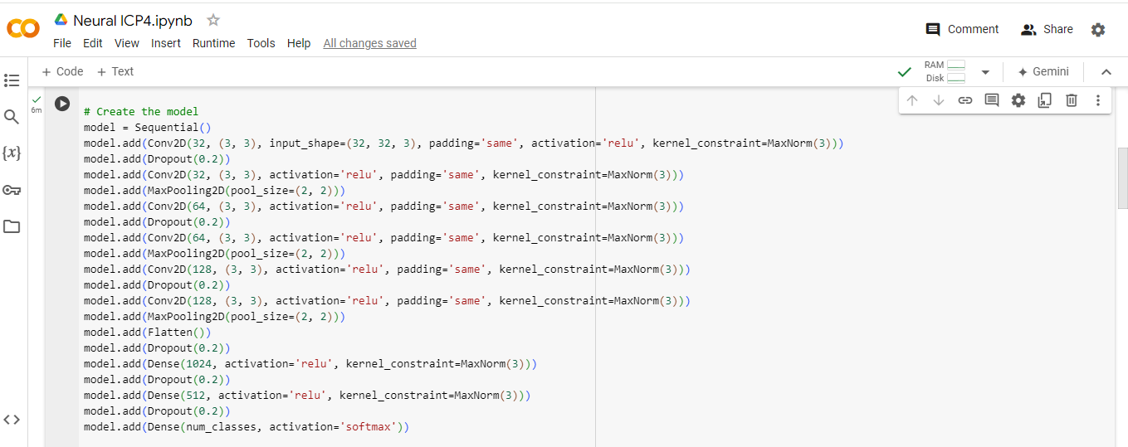

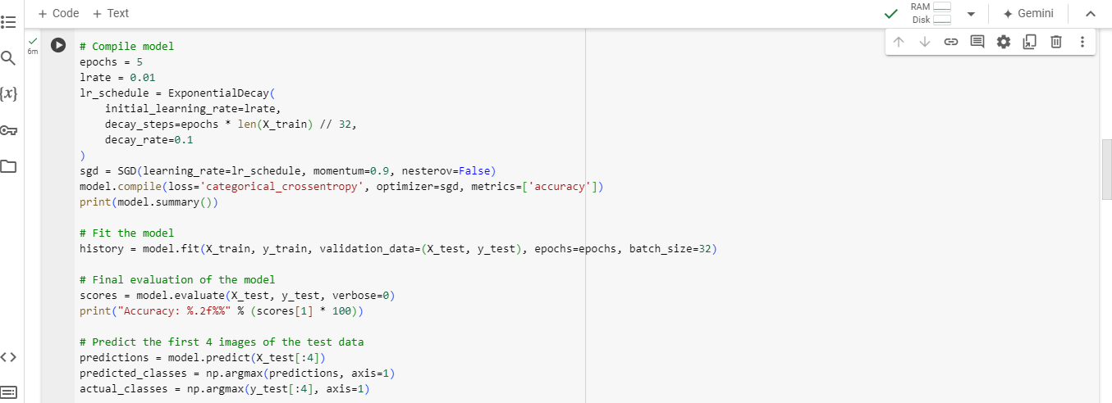

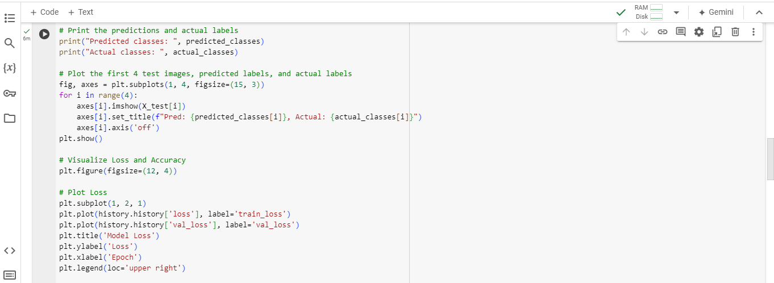

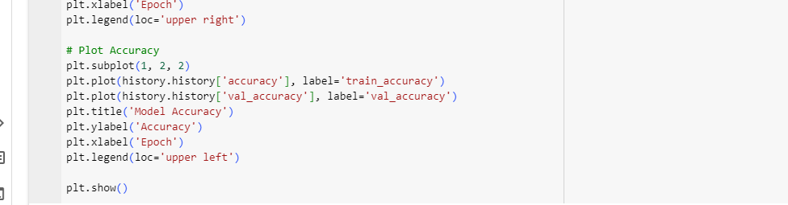

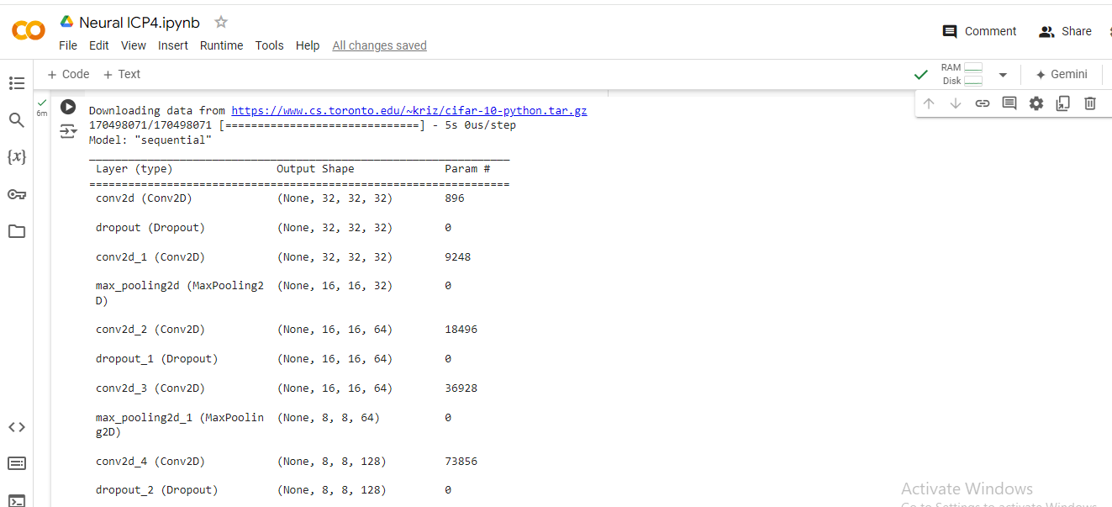

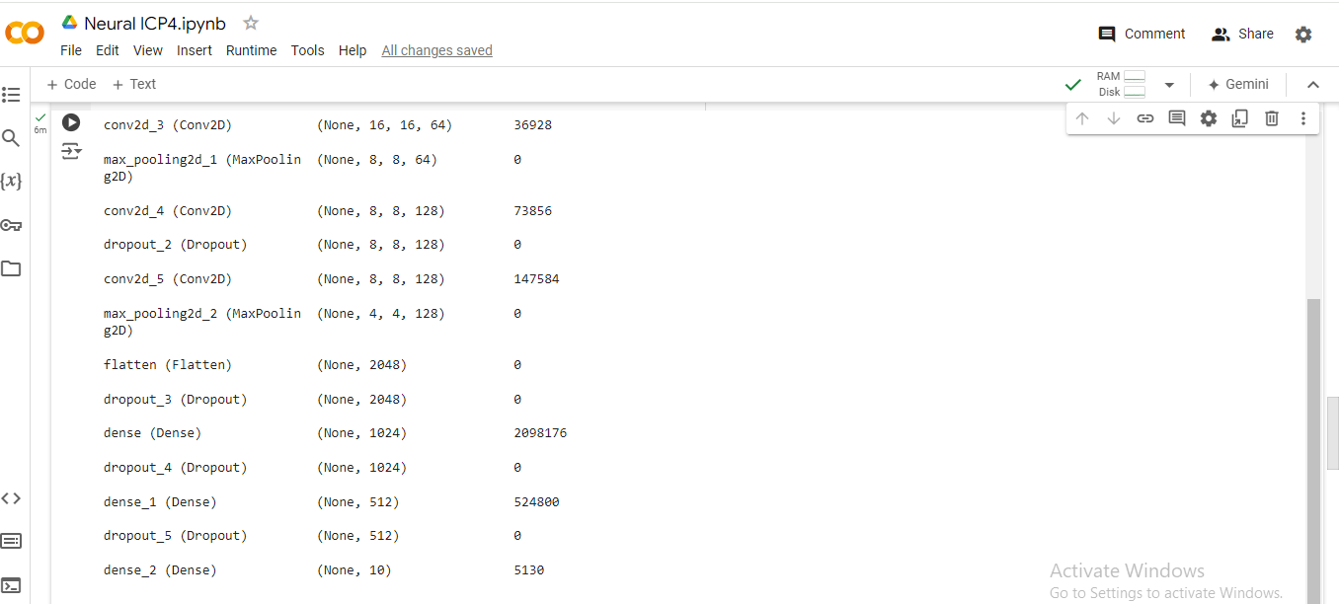

OUTPUT:

